DOCUMENTATION TO RUN TES CASES IN ECLIPSE

[Subtítulo del documento]

STEPS TO RUN TEST CASES IN ECLIPSE WITH SELENIUM

* Install the latest version of JDK of Java.

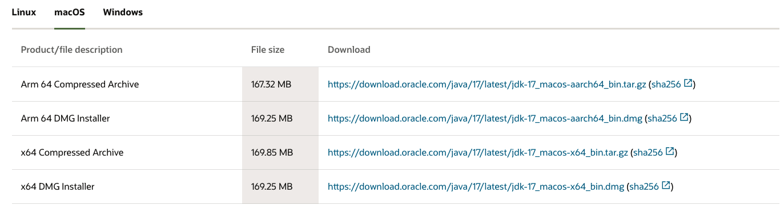

* Set the relevant environment variables.

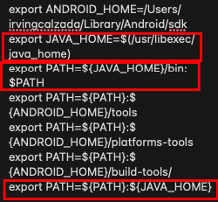

* Install Eclipse.

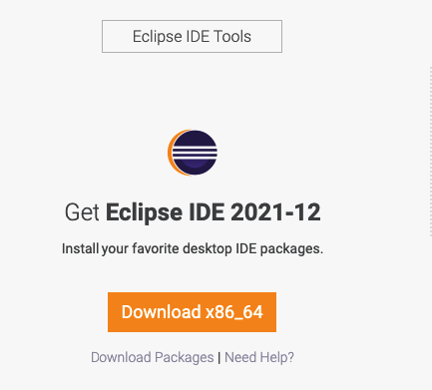

* Update google to the most recent version (Only if necessary).

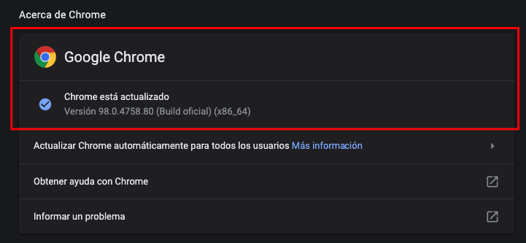

* Download chrome driver with the compatible version to the search engine in case it runs the automation and indicates a compatibility error with the driver.

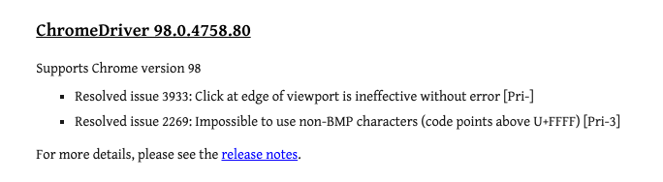

* Open Eclipse.

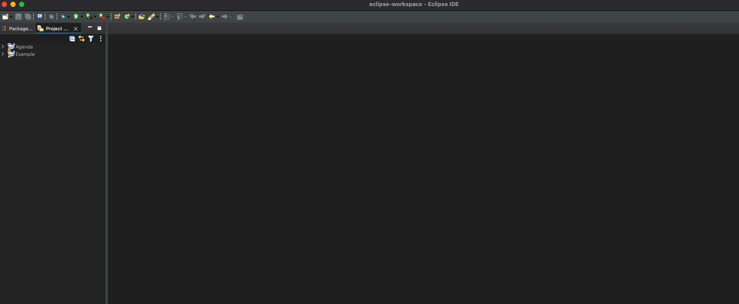

* Import the downloaded project for GitHub.

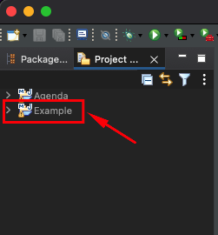

* Open the container class of the automated test cases, follow the next path:
  + Example/src/test/java/Test/DrataTest.

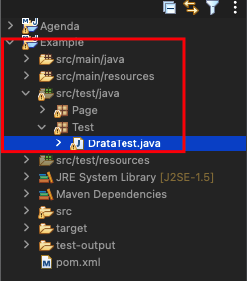

* In order to open the class that contains the test cases, click on the DrataTest.java Cases.

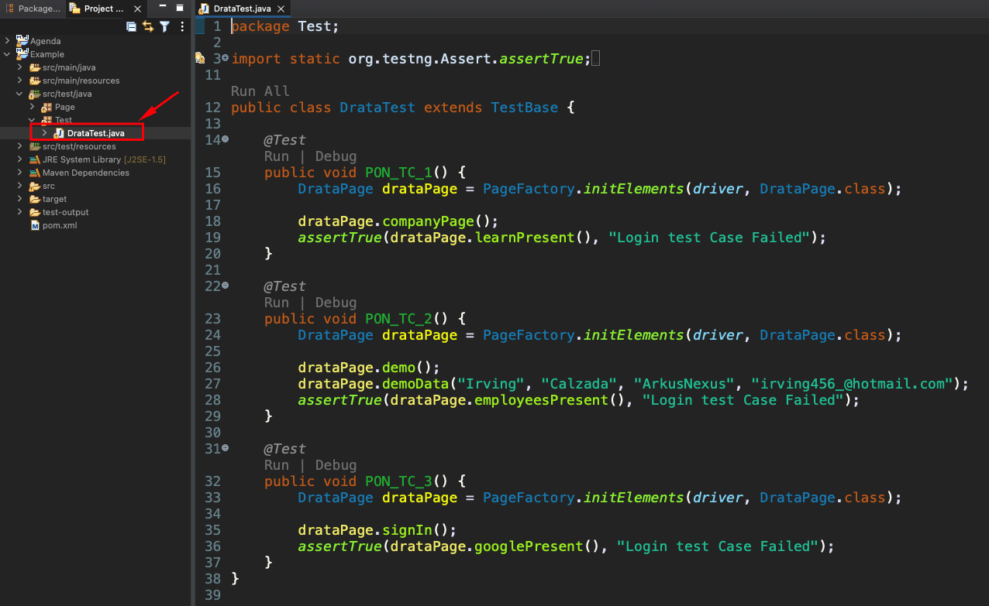

* To be able to run the cases there are two options:
  + Run all Test Case: This option is only if you want to run all test cases at once, for this you must click on the Run all option located under the imported libraries in the project.

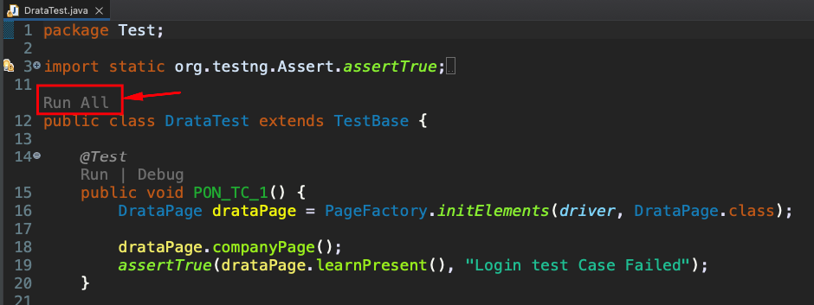

* + Run Test Cases individually: This option is viable if you only want to run on test cases at a time, for this you must click on the close-run option located. At the top that starts the test case method.

